**Heating Problem Set Validation Solutions**

2.

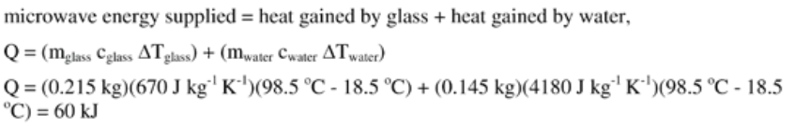

3.

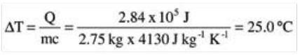

Final temp of soup = 20 + 25 = 45 ⁰C

4. 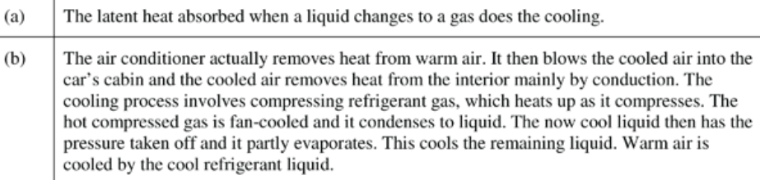

5. 